Team 11
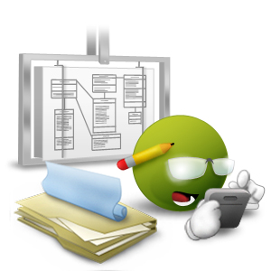ESTIMATION TECHNICAL AND METHOD
SOFTWARE MEASUREMENT AND ANALYSIS

Create by: Team 11
5/1/2012

Summary
Project estimation give an indicator of how long and what resources are required to complete a project. There are many methods available such as formalised procedures based upon database of historical metrics taken from completed projects and applied using mathematical calculation through to pure guesstimates using ‘feel-good’ figures for the various stages of a project.
This article presents an overview of the Wideband Delphi estimation technique, a relatively simple iterative method using experts (assumptions team members of Team 11) to provide input and actively take part in the estimation process. The article will describe the technique and how to apply it on software projects Viking Project, and also consider some of the benefits this technique can provide
Table of contents
1. Introduction 2
2. Estimation Methods 2
2.1. Wideband Delphi (WBD) Overview 2
2.2. Applying Wideband Delphi 3
2.3. Applying Wideband Delphi to estimation schedule of Viking Project 9
3. Estimation Result 12

List of figures
Figure 1: a Wideband Delphi session 4
Figure 2.Wideband Delphi process flow 4
Figure 3: Initial estimation chart from a Wideband Delphi session 7
Figure 4: Estimation chart showing three rounds from a Wideband Delphi session 8

List of tables
Table 1: Steps of estimation schedule 13

Introduction
Project estimates often have a habit of becoming predictions for the project schedule and resource requirements. However, no matter what estimation technique is used the result is still just an estimate. There is always a degree of uncertainty in the figures – hopefully this diminishes throughout the project lifecycle.
WBD uses an iterative process, in which each team member is an estimator and is responsible for producing an individual estimate for the project. Through a process of review and re-estimation convergence on an acceptable set estimation values is achieved.
The importance of estimation is to try using best efforts understand the size of the project. One of the best ways of achieving this and at the same time getting the project team agreeing with the estimates is to actively include the team during the estimation process.
One such estimation technique that follows this ideal is Wideband Delphi (WBD). With this technique the project team members actually perform the role of estimators.

Estimation Methods

Wideband Delphi (WBD) Overview
The Wideband Delphi estimation method can be summarized as follows:
- Select a team of experts, and provide each with a description of the problem to be estimated
- Ask each expert to provide an estimate (often anonymously) of the effort, including a breakdown of the problem into a list of tasks, and an effort estimate for each task.
- The experts then collaborate, revising their estimates iteratively, until a consensus has been reached
Using the Wideband Delphi method provides several advantages over obtaining an estimate from a single individual. First, it helps build a complete task list or work breakdown structure for major activities, because each participant will think of tasks. The consensus approach helps eliminate bias in estimates produced by self-proclaimed experts, inexperienced estimators or influential individuals who have hidden agendas or divergent objectives. People are generally more committed to estimates they help produce than to those generated by others. No participant in an estimation activity knows the "right" answer, and creating multiple estimates acknowledges this uncertainty. Finally, users of the Delphi approach recognize the value of iteration on any complex activity.
Situations in which the technique best applies:
- Particularly useful for high – mid level “initial” estimates – at the beginning or early phases of a project
Strengths:
- Helps get buy – in from the stakeholder
- It is a simple technique not requiring estimation experts
- Applicable to original projects where no previous metrics exist
- The process is an inclusive approach using all the project team to perform an active role in estimation
- Estimation figures are produced by team consensus through estimation iteration sessions. More likely to mitigate impact of large individual errors
- An expert judgement driven technique using developers to estimate. They are most likely to understand technical complexity and challenges when considering the requirements in context
Weaknesses:
- Must have strong facilitator for estimation sessions to remain unbiased
- Estimates are no better than the abilities of the participants

Applying Wideband Delphi
Wideband Delphi can be used to estimate virtually anything-the number of labor months needed to implement a specific subsystem, the lines of code or number of classes in an entire product
The Delphi method helps you develop a detailed work breakdown structure, which provides the foundation for bottom-up effort and schedule or size estimation. The starting point for a Delphi session could be a Vision document, a more detailed Requirements specification of the problem being estimated or an initial high-level architecture description, or a project schedule. The outputs are a more detailed project activity list; a list of associated quality, process-related and overhead activities; estimation assumptions; and a set of activities and overall project estimates, one from each participant.
Figure 1 illustrates the process flow for a Wideband Delphi session. The problem being estimated is defined and the participants selected during planning. The kickoff meeting gets all estimators focused on the problem. Each participant then individually prepares his or her initial activity lists and estimates. They bring these items to the estimation meeting, during which several estimating cycles lead to a more comprehensive activity list and a revised set of estimates. The moderator or project manager then consolidates the assorted estimation information offline, and the team reviews the estimation results. When some predetermined exit criteria are satisfied, the session is completed. The resulting range of estimates is likely to be a more realistic predictor of the future than any single estimate. Let's look at
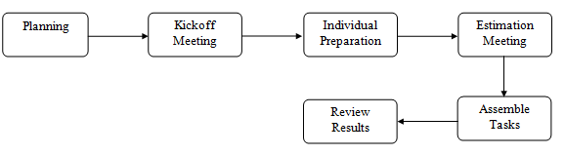
Figure 1: a Wideband Delphi session
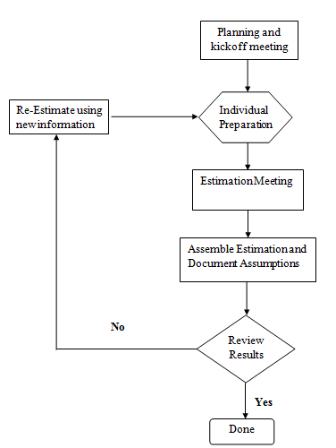
Figure 2.Wideband Delphi process flow
When planning a Wideband Delphi session, the problem is defined and the participants selected. The kickoff meeting gets all estimators focused on the problem. Each participant then individually prepares initial activity lists and estimates. During the estimation meeting, several cycles lead to a more comprehensive activity list and a revised set of estimates. The information is then consolidated offline, and the team reviews the estimation results. When the exit criteria are satisfied, the session is completed.
Planning
A Wideband Delphi session begins with defining and scoping the problem: vision, use case model, existing system, preliminary architecture. Large problems are broken down into manageable portions that can be estimated more accurately, perhaps by different teams. The person who initiated the estimation activity assembles a problem specification that will give the participants enough information to produce credible, informed estimates.
The estimation participants include a moderator, who plans and coordinates the activity, the project manager and two to four other estimators. The moderator should be informed enough to participate as an estimator but acts as an impartial facilitator who won't skew the results with his or her own biases or insights. The participants are selected because they understand the problem or project and associated estimation issues.
The Kickoff
An initial kickoff meeting of up to an hour gets all participants up to speed on the estimation problem. The moderator explains Wideband Delphi to team members who are unfamiliar with it and supplies the other estimators with the problem specification and any assumptions or project constraints. The moderator strives to give the estimators enough information to do a good job without unduly influencing their estimates.
The team reviews the estimation objectives and discusses the problem and any estimation issues. The participants agree on the estimation units they will use, such as weeks, labor hours, dollars or lines of code. If the moderator concludes that all team members are sufficiently knowledgeable to contribute to the estimation activity, the group is ready to roll. Otherwise, the participants may need to be briefed more fully on the problem they're estimating, or possibly replaced by others who can generate more accurate estimates.
To determine whether you're ready to proceed with the Wideband Delphi session, check your entry criteria-that is, the prerequisites that must be satisfied for you to proceed with subsequent process steps. Before you dive into the estimation exercise, ensure that the following conditions are satisfied:
- Appropriate team members have been selected.
- The kickoff meeting has been held.
- The participants have agreed on the estimation goal and units.
- The project manager can participate in the session.
- The estimators have the information they need to participate effectively

Individual Preparation
Let's assume that you wish to estimate the total amount of work effort (typically expressed in labor hours) needed to complete a certain project. The estimation process begins with each participant independently developing an initial list of the tasks that will have to be completed to reach the stated project goal, using a form like that shown in Figure 2. Each participant then estimates the effort each task will consume. Break each task down into activities that are small enough to estimate accurately. State the activities clearly, because someone will have to merge all of the participant activity lists into a single composite list. Total the estimates you produce for each project task, in the agreed-upon units, to generate your initial overall estimate.
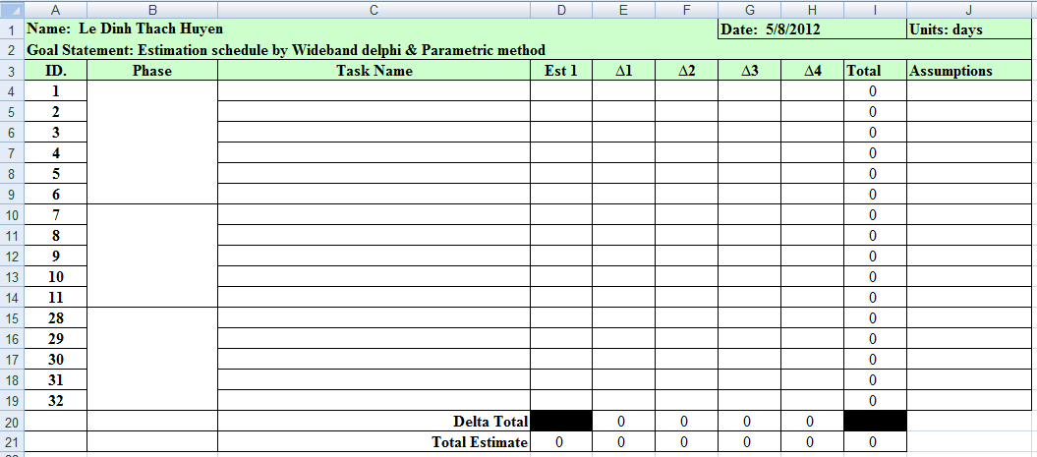
The estimation process begins with each participant independently using this form to develop an initial list of the tasks that will have to be completed to reach the stated project goal
Keep the following estimation guidelines in mind:
- Assume one person (you) will perform all tasks.
- Assume all tasks will be performed sequentially; don't worry about sequencing and predecessor tasks at this time.
- Assume that you can devote uninterrupted effort to each task (this may seem absurdly optimistic, but it simplifies the estimation process).
- In units of calendar time, list any known waiting times you expect to encounter between tasks. This will help you translate effort estimates into schedule estimates later on.
Estimation Meeting
The moderator begins the estimation meeting by collecting the participants' individual estimates and creating a chart such as Figure 3. Each participant's total project estimate is shown as an X on the "Round 1" line. Each estimator can see where his or her initial value fits along the spectrum. The initial estimates probably will cover a frighteningly large range. Just imagine the different conclusions you might have collected had you asked just one of the participants for his or her estimate and used that to plan the project.
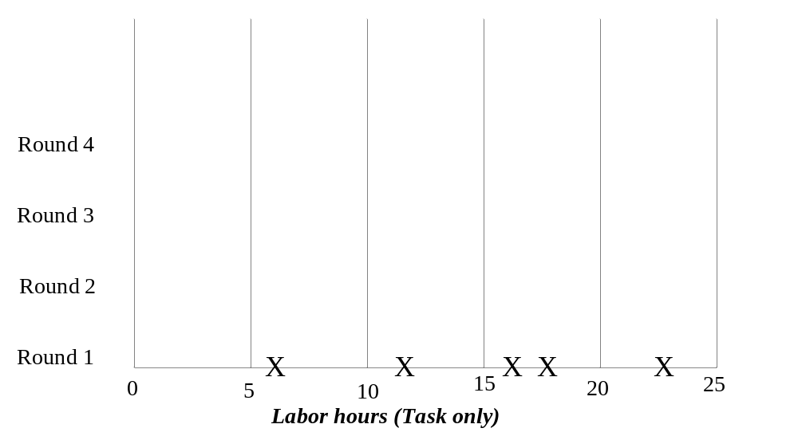
Figure 3: Initial estimation chart from a Wideband Delphi session
The moderator begins the estimation meeting by collecting and charting the participants' individual estimates. Each participant's total project estimate is shown as an X on the "Round 1" line. The initial estimates probably will cover a frighteningly large range.
During this initial discussion, the team members also talk about their assumptions, estimation issues and questions they have about the problem. As a result, the team will begin to converge on a shared set of assumptions and a common task list. Retain this final task list to use as a starting point the next time you must estimate a similar project.
After this initial discussion, all participants modify their estimates concurrently (and silently) in the meeting room. They might revise their task lists based on the information shared during the discussion, and they'll adjust individual task estimates based on their new understanding of the task scope or changed assumptions. All estimators can add new tasks to their forms and note any changes they wish to make to their initial task estimates. The net change for all tasks equals the change in that participant's overall project estimate.
The moderator collects the revised overall estimates and plots them on the same chart, on the "Round 2" line. I've done this on a whiteboard for easy visibility. As Figure 4 illustrates, the second round might lead to a narrower distribution of estimates centered around a higher mean than the mean of the Round 1 values. Additional rounds should further narrow the distribution. The cycle of revising the task list, discussing issues and assumptions and preparing new estimates continues until:
- You have completed four rounds;
- The estimates have converged to an acceptably narrow range (defined in advance);
- The allotted estimation meeting time (typically two hours) is over; or
- All participants are unwilling to alter their latest estimates
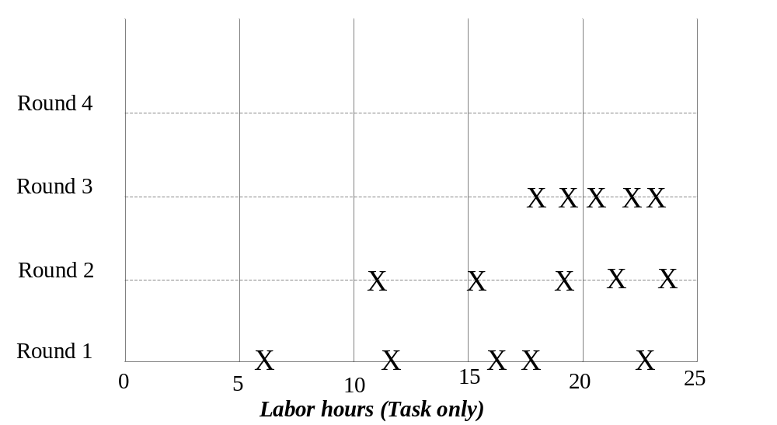
Figure 4: Estimation chart showing three rounds from a Wideband Delphi session
The moderator keeps the group on track, time-boxing discussions to 15 or 20 minutes to avoid endless rambling. The moderator should follow effective meeting facilitation practices, such as starting and ending on time, encouraging all participants to contribute and maintaining an impartial and non-judgmental environment. While preserving the anonymity of individual estimates is important for the first couple of rounds, the team members might agree at some point to put all their cards on the table and reach closure through an open discussion. This gives them a chance to discuss tasks for which their estimates vary substantially. Otherwise, though, the moderator should not identify the individual who produced each final estimate until the session is completed.
Assembling Tasks
The work isn't done when the estimation meeting concludes. Either the moderator or the project manager assembles the project tasks and their individual estimates into a single master task list. This person also merges the individual lists of assumptions, quality- and process-related activities, overhead tasks and wait times.
The merging process involves removing duplicate tasks and reaching some reasonable resolution of different estimates for individual tasks. "Reasonable" doesn't mean replacing the team's estimates with values the project manager prefers. Large estimate differences for apparently similar tasks might indicate that estimators interpreted that activity in different ways. For example, two people might both have an activity called "implement a class." However, one estimator might have included unit testing and code review in the task, while the other meant just the coding effort. All estimators should define their activities clearly to minimize confusion during this merging step. The merging step should retain the estimate range for each task, but if one estimator's task estimate was wildly different from that of the other estimators, understand it and then perhaps discard or modify it.
Review Results
In the final step, the estimation team reviews the summarized results and reaches agreement on the final outcome. The project manager provides the other estimators with the overall task list, individual estimates, cumulative estimates, assumption list and any other information. Bring the team back together for a 30- to 60-minute review meeting to bring closure to the estimation activity. This meeting also provides an opportunity for the team to contemplate this execution of the Wideband Delphi process and suggest ways it can be improved for future applications.
The participants should make sure the final task list is as complete as possible. They might have thought of additional tasks since the estimation meeting, which could be added to the task list now. Check to see whether tasks that had wildly different individual estimates have been merged in a sensible way. The ultimate objective is to produce an estimate range that allows the project manager and other key stakeholders to proceed with project planning and execution at an acceptable confidence level.
Competing the Estimation
The estimators have reached consensus on how their individual estimates were synthesized into a single set with an acceptable range.
Now you must decide what to do with the data. You could simply average the final estimates to come up with a single point estimate, which is what the person who requested the estimate probably wants to hear. However, a simple average is likely to be too low, and there's merit in retaining the estimate range. Estimates are predictions of the future, and the range reflects the inherent uncertainty of gazing into the crystal ball. You might present three numbers: the average of the estimates as the planned case, the minimum value as the best case and the maximum as the worst case. Or you could present the average value as the nominal expected outcome, plus the maximum-minus-the-average value, and minus the average-minus-the-minimum value.

Applying Wideband Delphi to estimation schedule of Viking Project
Collect data (prepare to schedule)
- Each member will collect data to estimate their own work. Data include process of a finished project, people join in project, size and duration of project, basic cost in same project (salary of programmer, designer .. and others). Average effort of each member in project and more.
- People can collect data from previous project, from completed project or on internet.
- People also collect data from current project, effort, time, current cost, budget …
- People also collect data from the same projects in progress in others team.
Work breakdown structure (WBS)
- WBS is a method help manager determine the tasks need to do in project. Use WBS will help team leader estimate resource for each task and for all tasks of project, estimate for project. Basically, it will be the target of estimation, people in team have to estimate from each unit (task) to high level stage. Estimate time, resource and cost for each task, each phase and all project.
- How to implement WBS ?
- First, we determine list basic phase of project (in Viking, they are plan, requirement, re-plan, design, implement, testing, deploy, close out and management).
- Next, based on personal experience, we will divide each phase into different parts. (example, in phase plan, we divide it into three parts: define goals, estimate and schedule).
- Next, based on above parts, we define what should we do to complete its and divide each part into tasks. Each task will be estimated and help team leader build schedule.
Estimate
  - In team, we use two method to estimate, wideband Delphi and parameter method.
  - How to use wideband Delphi and parameter method , we detail described in next sessions of document.
  - Estimate is a hard stage.
- Team leader has to know what is the input – output, resource, time, cost before project is began. Estimate stage is implemented in each phase at begin or after finish a milestone of project. Estimate will help team leader capture progress of project
Schedule
- Team leader will use estimation result and WBS to schedule.
- WBS provide tasks for schedule and estimation result will provide data. Team leader can assign resource and others information in schedule. After schedule, team leader should share and discuss with team member.
Purpose
- Help project team estimate (risk, time, resource and budget) and define works base on Work Breakdown Structure.
Input and out put
- Input: vision and scope document, or other documentation that defines the scope of the work product being estimated. In team assignment 13, input is Viking URD document, Work breakdown structure document.
- Output:
- Estimate for each task defined in WBS (present as detail schedule, include work, time, resource, cost and budget ).
- Delphi form.
- Wideband Delphi form.

In theory | In team assignment 13
Choosing the team. The project manager selects the estimation team and a moderator. The team should consist of three to seven project team members. The team should include representatives from every engineering group that will be involved in the development of the work product being estimated | First, we do not choose a team, together, we prepare for a meeting. Team leader will introduce what thing we need to do in project, step by step. Goals of project and basic process, “design – code – test” ..  A member will assigned to prepare for next meeting – kickoff meeting, who will draft a list of basic work (detail described in next step).
Kickoff meeting. The moderator prepares the team and leads a discussion to brainstorm assumptions, generate a WBS, and decide on the units of estimation | Before this meeting, a member will draft a list of basic work need to be completed in project. The moderator will leads a discussion to brainstorm assumptions, generate a WBS, and decide on the units of estimation, like in theory.  WBS will be built base on the project development stage, top-down, from basic to detail. Begin at requirement, design, code and test phase. Each phase will be discussed to identify how to complete this phase. Split work into several parts and so on until work can be easily estimated resources and effort.
Individual preparation. After the kickoff meeting, each team member individually generates the initial estimates for each task in the WBS, documenting any changes to the WBS and missing assumptions | Each member will complete his/her Delphi form with estimation for each task (in this case, task is basic unit should be estimated), time, cost, resource and assumption. They can use their own ways to estimate.  All member will send their Delphi form to team leader.  Delphi form have delta columns that members fill their estimate in. Delta 1 is the first individual estimation, delta 2 is second and delta 3 is third and so on.  After each phase of project or after finish estimation session step, team member should re-estimate and update by fill in delta columns.
Estimation session. The moderator leads the team through a series of iterative steps to gain consensus on the estimates. At the start of the iteration, the moderator charts the estimates on the whiteboard so the estimators can see the range of estimates. The team resolves issues and revises estimates without revealing specific numbers. The cycle repeats until either no estimator wants to change his or her estimate, the estimators agree that the range is acceptable, or two hours have elapsed. | Team leader will collect all member Delphi form and prepare for estimation meeting.  In meeting, team leader will ask each member why can and how do they estimate. Each team member must explain about the way to estimate, formula or something else.  Leader have responsibility to focus on members with estimation that have much time, source, budget… find out why they estimate that. If leader find out anything uncertainty, leader will refer the matter to discuss and after ask that member to re-estimate in meeting.
Assembling tasks. The project manager works with the team to collect the estimates from the team members at the end of the meeting and compiles the final task list, estimates, and assumptions. | End of estimation meeting, leader will collect all team members data and make a wideband Delphi report, estimate for project.
Reviewing results. The project manager reviews the final task list with the estimation team
Table 1: Steps of estimation schedule

Estimation session Ground Rules
- All estimation sessions must be performed individually with no pair or group interaction.
  - This is important to ensure that individual bias does not skew results
  - Also individual estimation is likely to reveal a wider number of activities that need to be taken into consideration
- Estimators must ignore external influencing factors – i.e. perceived expectation of a
  - The aim is to achieve consensus amongst the team on a realistic figure rather than provide one that the project sponsor wants to hear
- Estimators must indicate factors affecting their figures
  - This can help build a clearer picture of the task list
- Estimators will ignore holidays and other similar factors
- Ignore unnecessary complexity during the estimation process. Apply these factors when defining the actual project timescale estimation
- Anonymity must be observed during the whole estimation process.
  - It is essential that the facilitator ensures bias does not creep into the process.
  - Estimators must not reveal which figures they derived
- Estimation sessions ideally have a predefined time limit.
  - Don’t worry about getting it wrong (its an estimate anyway) and figures can be refined during successive iterations.
  - Helps to maintain focus, continuity and progress

Estimation Result
References attachment folder:
“2.0. Estimation Schedule Result”

